Panopto in Canvas

Introduction
This guide to using Panopto in Canvas is written to cover everything you need to know to get started in one space. You will see there are links to videos within this document. The linked videos show you a demonstration of the action being described in the document. One thing to be keenly aware of is that we would never just throw something like this at you and not be available for training. If you feel like you need help in addition to reading this document, please email the IT Helpdesk (helpdesk@wilson.edu).

What is Panopto?
Panopto is a system to record, store, and view videos online. We have integrated Panopto with Canvas to make it easier for faculty and students to use.
Introduction 1
What is Panopto? 1
What are the pedagogical uses of Panopto? 2
What equipment do I need? 2
Equipment for recording yourself at your PC 3
Equipment for recording a lecture in your classroom 3
Equipment for mobile recordings 3
How to get help: 3
Wilson-Provided Training 3
Panopto-Provided Training 3
How will my students view my videos? 4
My Folder 4
Course Folders 4
How do I activate Panopto in my Canvas Course?(Click Here to view the video) 4
Note: Panopto will make you log into your Canvas account to watch the sample videos on this document. 5
Activate Panopto in your Canvas Course 5
Organize your desired folders for the course 5
How do I record a video? (Click here to view the video) 8
How do I Upload a video I recorded using something else? (Click here to view the video) 10
How can my students watch my videos? (Click here to view the video) 11
What do I do with my videos when I copy a course to another semester? 11
What do I do if I want to let other professors use my videos in their own courses? 11
Other Items for Collaboration 12

What are the pedagogical uses of Panopto?
There are many pedagogical uses of Panopto that will benefit your students. Here are some examples:
- Flipped Classroom Lessons--Deliver content via video outside of class to free up class time for more engaging learning.
- Lecture Capture--Record the lectures you do give in class so your students can review the recording later.
- Record Outside of the Classroom--Use your cell phone or other camera to record experiences outside of the classroom for your students to view later.
  - Example: A History Professor visits a Civil War reenactment. You can bring it back to your students via video.
- Student Assignments--We can set up assignment folders that allow your students to record and upload video to discussion boards or assignments.
  - Example: Education students record themselves leading a group through a Jigsaw activity.
- Anything else you can think of. There are no limits here.

What equipment do I need?

Equipment for recording yourself at your PC
The key to equipment is knowing that you need to capture video and audio. If you are recording yourself right at your computer and you are the only one speaking then you can use a standard webcam and a headset like the one in this link. Note: Panopto doesn’t require the headset, but if your PC’s microphone isn’t very good, you’ll want a headset. If you don’t plan on having your face on the screen, then you don’t even need the webcam.

Equipment for recording a lecture in your classroom
For recording a lecture in a classroom, you don’t want to have to walk around wearing a headset. For this reason, you will want to use a webcam that has a good microphone built in. I have tested the webcam in this link and it works very well. You can view a trial video using the recommended webcam here. If the demand is there, the Library will purchase a few of these webcams to lend out to faculty for lecture capture purposes. Please contact James D’Annibale if you plan on doing lecture capture and would require a borrowed webcam.

Equipment for mobile recordings
You can upload video from cell phones, camcorders, etc. If you are out and about and need to record something for your students, just use what you have.

How to get help:
With Canvas we have 24/7 support via phone and chat. With Panopto, we have great support but end-users like faculty and students cannot submit help tickets. To get help with Panopto, please contact the Help Desk at 717-264-4001 or email helpdesk@wilson.edu.

Wilson-Provided Training
Please contact the IT Helpdesk (helpdesk@wilson.edu) for individual or group training and a member of the Instructional Design Team will reach out to you.

Panopto-Provided Training
Another thing you can do is participate in a free basic training webinar provided weekly by Panopto. You can sign up here: https://support.panopto.com/webinars
There is also a Friday Q&A session available from that same page.

How will my students view my videos?
As mentioned above, Panopto is integrated into Canvas. This creates a clear connection between you and your students. Every “Teacher” in Canvas is a “Creator” in Panopto and every student in Canvas is a “viewer” in Panopto. Panopto Creators will get folders to hold videos.
If your students would like help with Panopto, please send them to these two pages:
Students Viewing Panopto Videos: https://onlinelearning.wilson.edu/courses/21/modules/items/106834
Students Recording and Uploading Panopto Videos: https://onlinelearning.wilson.edu/courses/21/modules/items/106835

My Folder
You will get a “My Folder” which you can use to hold videos that perhaps you use for more than one class. To share videos in your “My Folder” you can give viewers the link to each video. Links could be placed within any page or post in Canvas or could be listed as an external url in a module.

Course Folders
You will also get a folder for each Canvas course. Students enrolled in a course will automatically have viewing rights to the course folder. If you would like to make certain videos private, I recommend you place them into a folder that is set to be unavailable to viewers (Settings--Availability) Videos in the course folder can be viewed from the Panopto menu item, embedded into a page or post, or could be listed as an external url in a module (more on this below).

How do I activate Panopto in my Canvas Course?(Click Here to view the video)

Note: Panopto will make you log into your Canvas account to watch the sample videos on this document.

Activate Panopto in your Canvas Course
Step 1: Enter your course and click Settings in the course menu
Step 2: Go to the Navigation tab at the top of the Settings page
Step 3: Find Panopto Recordings at the bottom. Click on the option wheel and select “Enable.” Then be sure to click “Save”
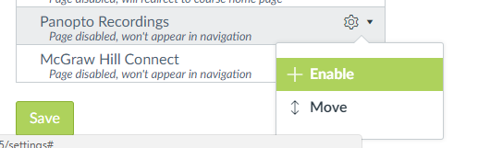

Organize your desired folders for the course
Step 1: Think about how you will use Panopto. If you will only record one type of video then you can just stick to the Default folder. However, if you will be recording lectures, off-campus events, etc. you may wish to have folders for each type. That is totally up to you. To add a folder, simply click “Add folder” and give it a name (Note: after typing the name of the folder, use your enter key).
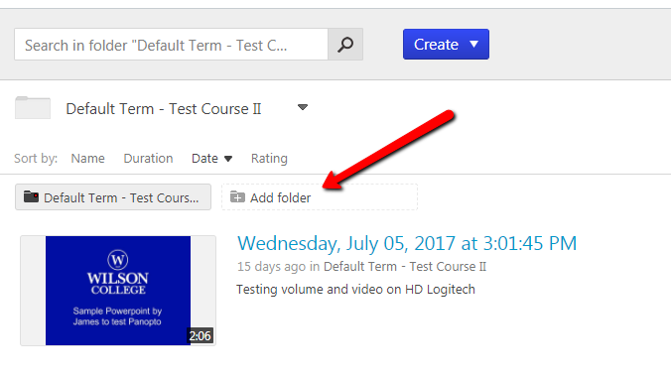
Step 2: If desired, create an assignments folder for your students to use. Note: By default, students will not be able to view each other’s videos.
Follow these steps to create an assignments folder:
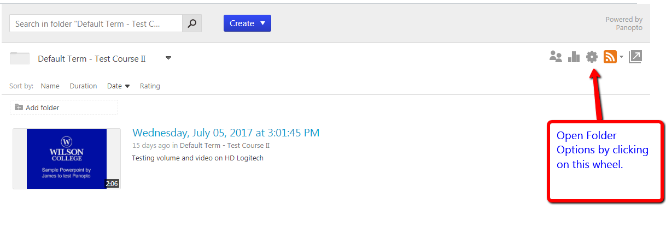
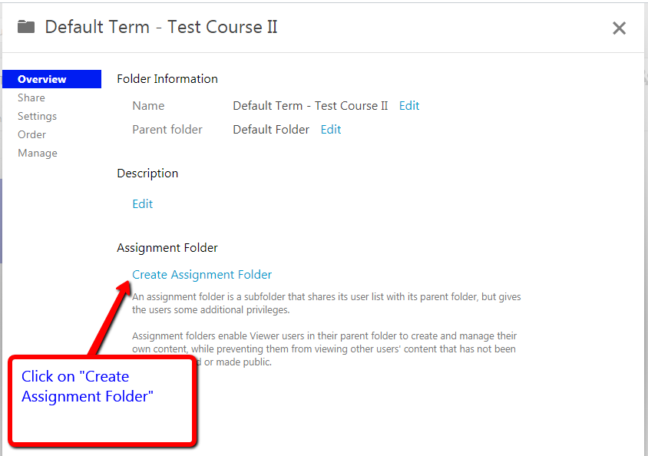

Step 3: If you would like students to be able to post Panopto videos to Discussion Forums, you will need to create 2 folders. First you will create a folder called Discussions (See Step 1 of Organizing Folders). Then from within that Discussion folder you’ll want to create an assignment folder. This will be a 2nd assignment folder meant for discussions only. We will then make that particular assignment folder have sharing permissions so students can see each other’s videos. Follow the steps below.

- From the Default Folder area Create a Discussions Folder (see instructions above)
- Create an assignments folder within the Discussions Folder (see instructions above) note: you will need to click on the options wheel for the Discussions Folder
- Enter the Discussions Assignments folder and click on the option wheel for that folder.
- Click on Settings and then Allow viewers to see each other’s sessions
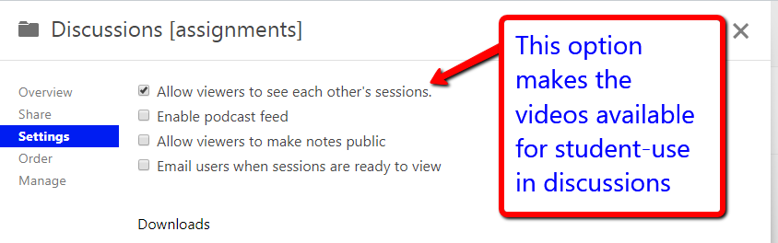

How do I record a video? (Click here to view the video)
Step 1: Click Create and then click Record a new session
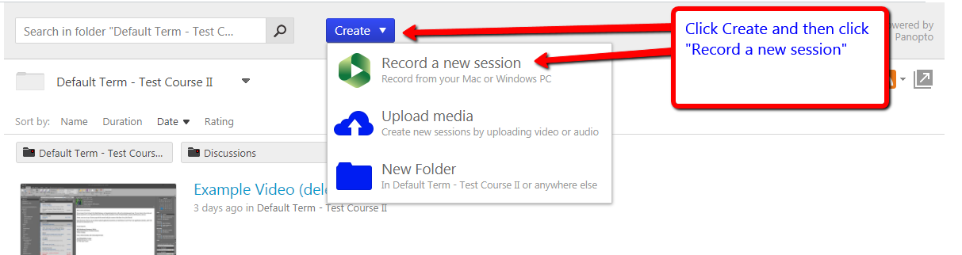
Step 2: Download the Panopto Recorder if you haven’t done so already. If you already have the recorder you will click Open Panopto. Your web browser may pop up with an additional prompt asking if you are sure about opening Panopto. Go ahead and click Open, Ok, etc.
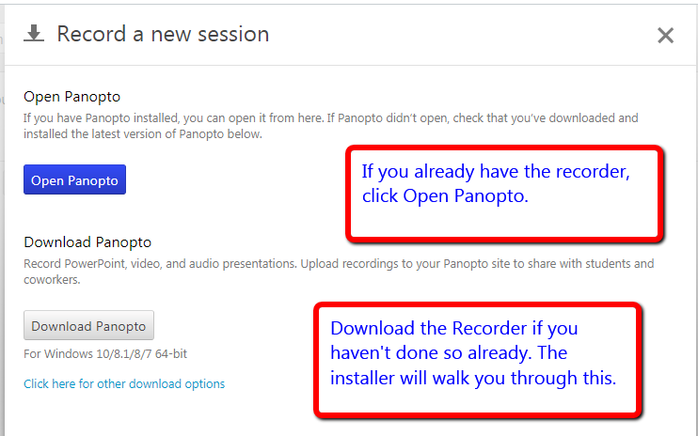

Step 3: Select your audio/video sources and then record.
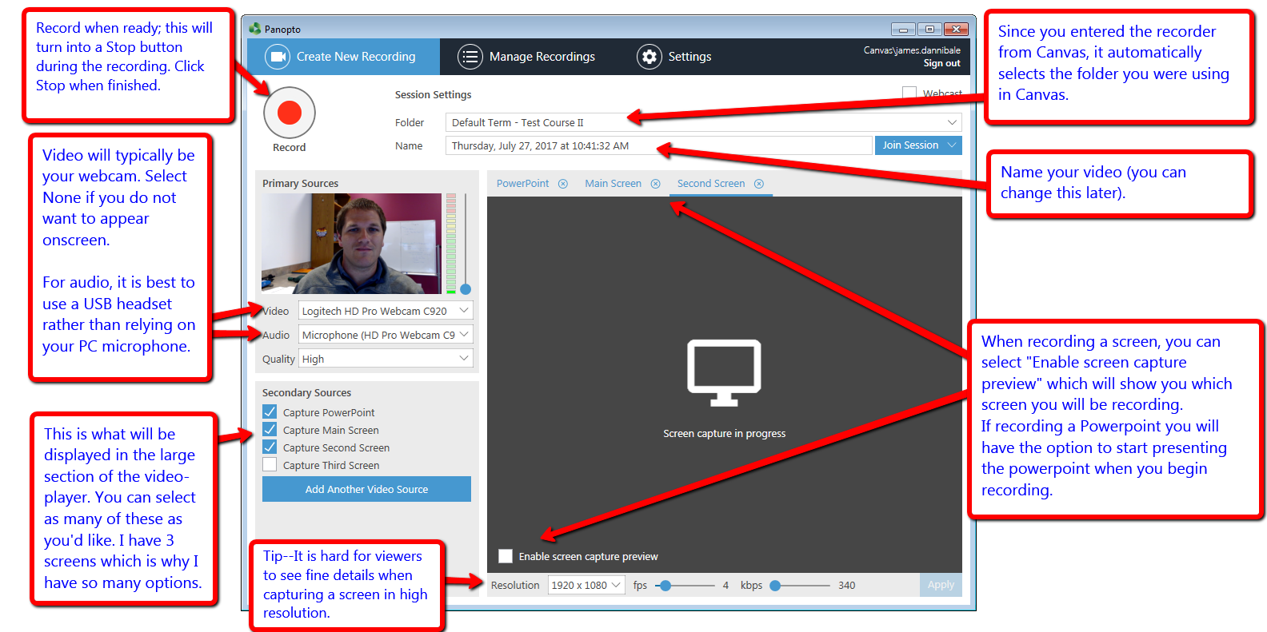

Step 4: Upload your video. This will actually happen automatically once you click upload following your recording.

How do I Upload a video I recorded using something else? (Click here to view the video)
Step 1: Click Create and then Upload media
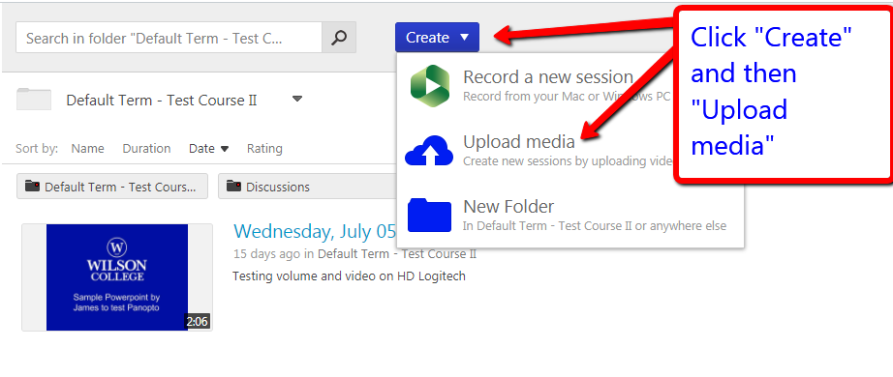

How can my students watch my videos? (Click here to view the video)
There are 3 ways for your students to access and watch your videos:
Option 1: Students click on “Panopto Recordings” in the course menu list and view videos there.
Option 2: You share the link to the video as an “external url” within a module. To find the video link, click on your video’s “Share” settings and the link will be at the top.
Option 3: Embed the video into a content page, discussion board, quiz, etc. To do this, click on the Panopto button within the Rich Content Editor and your available videos will appear.

What do I do with my videos when I copy a course to another semester?
Email helpdesk@wilson.edu and let IT know that you need this to happen and they will take care of it.

What do I do if I want to let other professors use my videos in their own courses?
You have two options:
Option 1: Provide the link of the video to your colleague and s/he can add the link as an external URL into his/her Canvas course. *Note: This is the quicker/easier option* To get the link, put your mouse over the video and select Share. The “Who has access” area will be “Specific People.” Click on that and change it to “Anyone with the link” and then copy the link at the top of that page. This option keeps the “owner” of the video as the original person who recorded it. Option 2 transfers the ability to edit the video.
Option 2: Email the IT Helpdesk (helpdesk@wilson.edu) and request to copy the videos into the required folder. They will need to know the original course, video titles, and destination course.

Other Items for Collaboration
There are some other things we can do to facilitate collaboration. For example, if all Nursing professors want to share a folder, we can create a folder you all have access to.

